Install Git Environment

# Install Git Extensions

<http://code.google.com/p/gitextensions/>

# Install msysgit

<http://msysgit.github.io/>

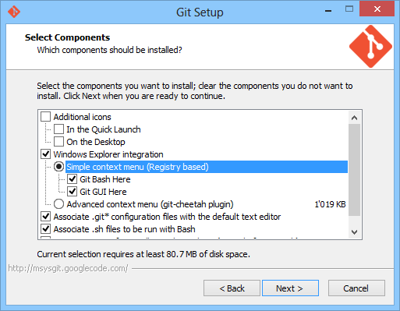

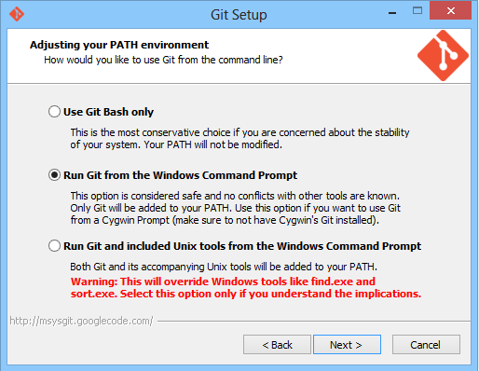

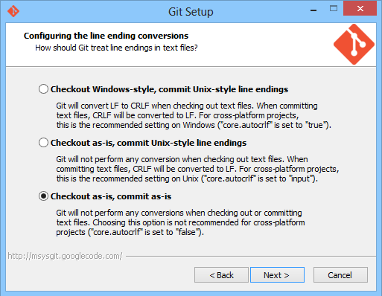

# Create Public and private Key

Go to C:\Users\<Username>

right click (empty space)

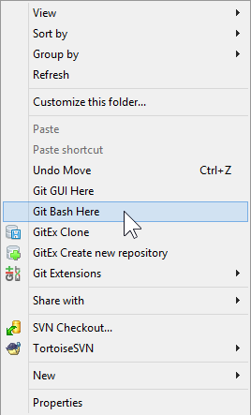

Generate key with: **ssh-keygen**

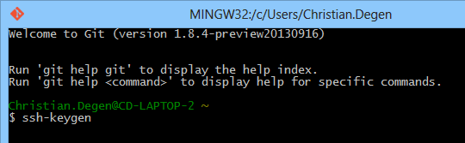

This generates a .ssh folder inside C:\Users\<Username>

Run puttygen.

C:\Program Files (x86)\GitExtensions\PuTTY\puttygen.exe

**Load** the generated key: C:\Users\Christian.Degen\.ssh\id_rsa

**Save private Key** as <yourName>.ppk

Copy id_rsa.pub to the Git-Server.

# Register on Sever

Acces the linux server with an admin account.

Copy the public key to the $HOME/gitolite-admin/keydir folder, and rename it to match the user name (e.g. simone.pub)

Edit the config file ($HOME/gitolite-admin/conf/gitolite.conf) and add the user to the repository users (e.g. R = simone)

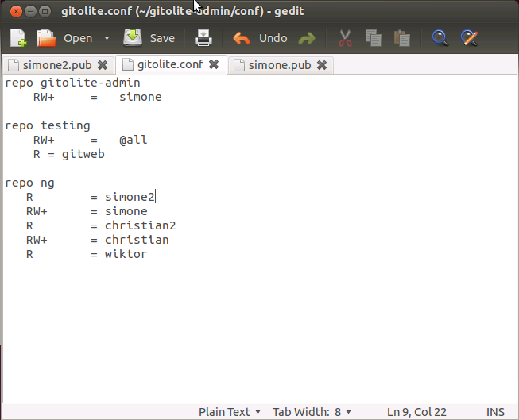

Open a terminal

You need now to add, commit and push the edited files to the special gitolite admin repository:

Access gitolite-admin folder ($HOME/gitolite-admin)

Add modified files: execute **git add conf keydir**

Commit: execute **git commit –m ‘added user xxx’**

Push: execute **git push**

# Create Test Repository on local machine

Create new folder

Right click: select **GitExt Clone** from context menu

**Load SSH key** (the private one <yourName>.ppk)

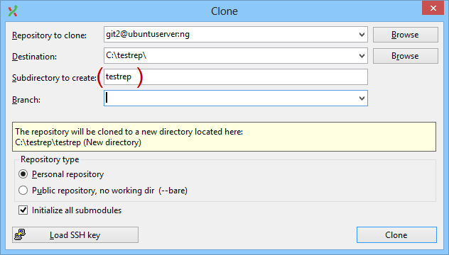

**Clone** opens cmd.

Hit **y**

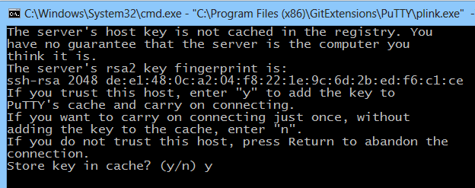

Close CMD

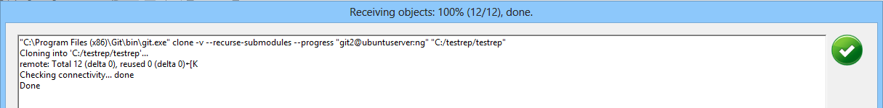

# Test Commit

Make a change to the test.txt

Right click your local repository folder

**GitExt Commit**

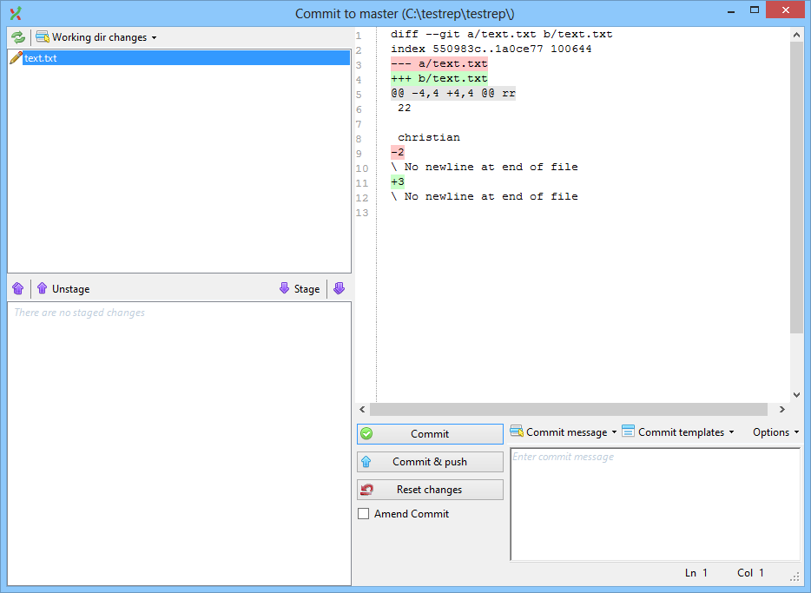

**Stage**

Enter a commit message

**Commit & push**

